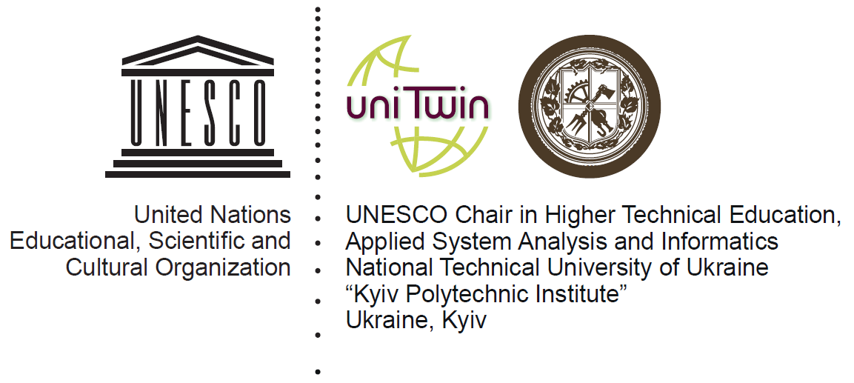

NTUU"KPI" (37 Peremohy ave., Kyiv)
XХIIth INTERNATIONAL SCIENTIFIC AND PRACTICAL ONLINE - CONFERENCE
RENEWABLE ENERGY AND ENERGY EFFICIENCY of the XXI CENTURY
May, 20th – 21th, 2021

REGISTRATION FORM

Name: _______________________________________________________________________________
Position: _____________________________________________________________________________
Academic degree: ______________________________________________________________________
Organization: _________________________________________________________________________
_____________________________________________________________________________________
Mailing address: _______________________________________________________________________
_____________________________________________________________________________________
Phone.: ____________________________________
Fax: _______________________________________
Е-mail: _____________________________________

Report title: ___________________________________________________________________________
_____________________________________________________________________________________
____________________________________________________________________________________
Please book hotel rooms for _____ people from _____.05.2021 till _____.05.2021
Date ________________ Signature ___________________
*Registration form should be sent back:
by e-mail: info@ive.org.ua or
by fax: +38 (044) 206-28-09
Should any questions arise don’t hesitate to contact organizing committee:
Phone/fax: +38 (044) 206-28-09
e-mail: info@ive.org.ua

